Empower Workers with Knowledge and Skills Through Edutainment

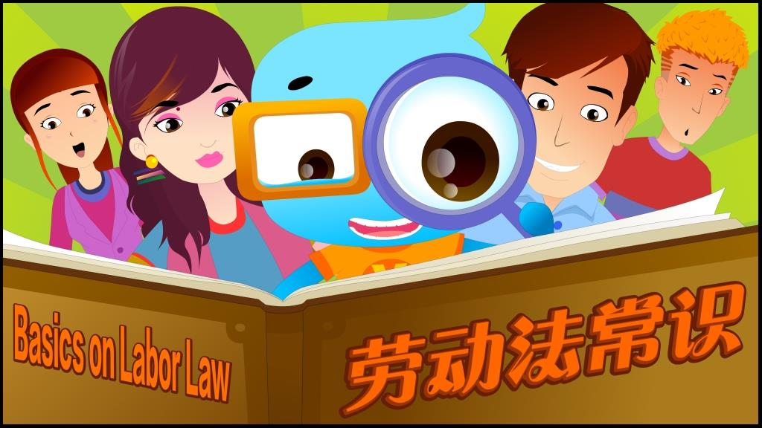
Verité is currently offering 10 E-learning courses on worker-selected life skills and labor topics that ‘teach’ through entertainment.

The modules, in cartoon and live video formats (delivered in Chinese with English subtitles), feature recurring characters who illuminate issues and their solutions with humor and personal appeal in everyday factory situations. Interactive prompts measure student reactions, understanding and commitment to new behaviors.

The 10 courses include:
No. | Module Title | Format | Lengths
1 | Communication and Grievance:  Skills and Pathways for Resolving Problems at Work and in Life | Mini-movie | 20 min
2 | Basics of Chinese Labor Law:  On Wages, Hours, Overtime, Leave and Benefits | Cartoon | 15 min
3 | Basics on Labor Contract Law:  Protections and Benefits of an Employment Contract | Mini-movie | 12 min
4 | Core Labor Rights / Code of Conduct:  Forced Labor, Child Labor, Freedom of Association, Discrimination | Cartoon | 15 min
5 | Personal Hygiene and Infectious Disease Prevention:  Controlling Infection for Yourself and Those Around You | Cartoon | 16 min
6 | Nutrition and Health:  Diet and Exercise Tips for a Longer and Happier Life | Cartoon | 16 min
7 | Stress Management:  Understanding & Reducing Anxiety, Depression &Related Illnesses | Cartoon | 13 min
8 | Managing Personal Finances:  How to Budget and Save for the Future | Cartoon | 14 min
9 | Managing Personal Relationships:  The Power of Empathy, Understanding and Respect | Mini-movie | 17 min
10 | Personal Protection:  Managing Risks of Sex Before Marriage, Contraception, Abortion, and Sexual Harassment at Work | Cartoon | 16 min

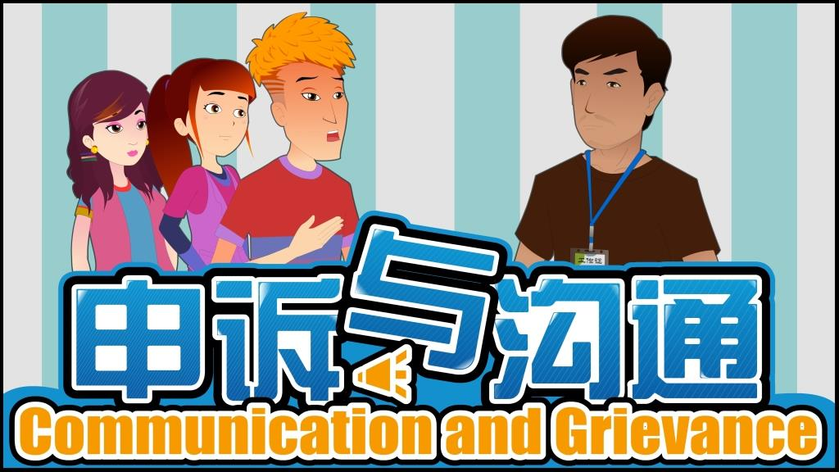
The modules Provides workers:
- Knowledge, skills and mechanisms
to identify and participate in resolving
work place issues
- Life skills and information to protect
their personal health, safety and opportunities

Provides suppliers:
- Cost-effective worker training on rights, responsibilities, wellness and other worker-chosen topics that improve worker satisfaction and performance
- Support for worker-management communication and grievance resolution

Access:
The training videos and interactive computer applications are loaded onto the workers training website, which can be accessed at http://tr.verite-china.org/.

Participants will need to register on the site and obtain a course code in order to access the training courses either via computer or smart phone. A mobile app for Android phones is provided on the worker training website for downloading. The website also provides a set of other learning resources including Chinese labor laws, more reading materials on topics related to all 10 training courses, and an on-line consultation center that answer workers’ questions and concerns. A learning database is designed to capture participants’ learning progress as well as to evaluate student reactions to and understanding of the training content and commitment to new behaviors. Progress of learning can be tracked and reported regularly based on client needs. Mobile outreach will be conducted to refresh learning and assesses impact over time.
The content of the website is in Chinese; an English version of site navigation framework is also available on the web site to allow for non-Chinese speakers to access the content.

